#### ­Introduction

This test will allow the candidate to demonstrate problem-solving skills along with competence with JavaScript, CSS3 and HTML5.

#### Task

Candidates are required to display on screen 6 bingo tickets with correctly positioned numbers. The use of 3rd party libraries/toolkits should be justifiable. Candidates will be assessed on the quality of their JavaScript/CSS code and responsive design. Image assets provided are entirely optional in the candidate’s implementation.

##### Ticket Format

A bingo ticket is made up of 15 numbers sorted into 10 columns and 3 rows. Each column contains a set range of numbers. The first column contains the range 1-9, the second 10-19 and so on. The final column contains numbers within the range of 80-90.

##### Ticket String

*011722475204365360702637497481233455758302154058881928446789061241507324334876840738576186051132437816395663800818206590104559628214294664710935667287132130687703253151692742547985*

This string of 180 numbers contains every number between 1-90 and represents the numbers for a strip of 6 tickets. The task is to create and populate the 6 tickets using this ticket string.

Each ticket contains 15 numbers. Each number is represented by 2 digits, so that the first ticket’s numbers are the first 30 numbers in this string and so on. The finished product can be seen at the end of this document.

#### Animation

Additional skills may be demonstrated in the some form of CSS/JavaScript animation on the tickets. Transition animations on tickets, rollovers, numbers animating, sprite sheets etc.

#### Submission

Please submit an output of your final results and all source code back to us.

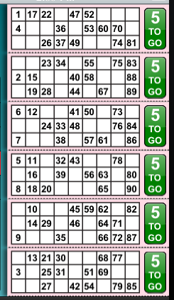

End product.